Price List

Routine Exam and Treatment plan    40  
TMJ consultation                                80  
emergency exam/appointment           60  
Prescription ( free with exam)             25

x-rays

small                          20                                  
Large (OPG)              60

Referral X-ray (OPG) 90  
CBCT scan                 from 120  
CBCT (referral)           from 180

scaling and polish       60

Fillings (white only)

single surface                from 90  
two surfaces                  from 120  
three or more surfaces  from 140  
composite onlay/inlay    from 250  
ceramic onlay/inlay        from 400

Root canal Treatment  
Front Tooth                   400  
Premolar                       550  
Molar                             750  
  
Tooth Extraction  
Routine extraction            from 100  
Surgical Extraction           from 180  
Wisdom tooth extraction   after exam  
  
Dentures  
Acrylic Dentures            from 450  
Metal Dentures              From 600  
  
Veneer  
Porcelain                     from 700  
Composite                   from 250  
  
Crowns  
Post-core                           275  
Metal crown                       350  
Porcelain fused to Metal    550  
zirconia/E-max                   700  
  
Fixed bridge             from 1100

Teeth Whitening  
Home whitening Kit            250  
whitening refills                   35  
Zoom Whitening                 300  
  
Dental Implants  
Consult                            60  
Single Implant                from 1300

Implant crown                 From 1100  
Bone Augmentation        From 250  
  
Kids Routine exam        35  
kids scale & polish         35  
Fissure sealants             40 per tooth  
tooth extraction              from 70  
filling white only              from 80  
  
Orthodontics  
Fixed braces                  from 3500  
clear braces                   from 2800

Email –

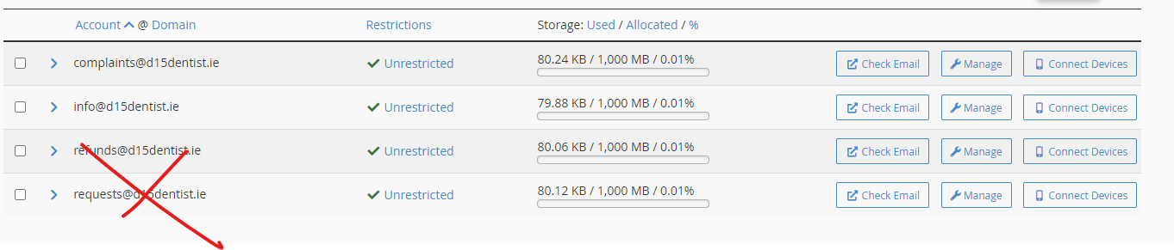

[bills@d15denstist.ie](mailto:bills@d15denstist.ie)

Observation and genral points.

1. Book an appointment button
2. Referral page - <https://www.mintclinic.ie/referrals/>



1. Orthodontics
2. TMD
3. Sleep apnoea
4. Headache and migraine

- Overall the design looks modern and fresh. Good pick.  
- Nice pictures selected for the home page. It creates a high-quality image of the clinic  
- Great that you made a sticky top line with "Book an appointment" well-visible

----- book appointment in side

Address update

Phone no update

~~GP button.~~

~~Remove play video – by gp button.~~

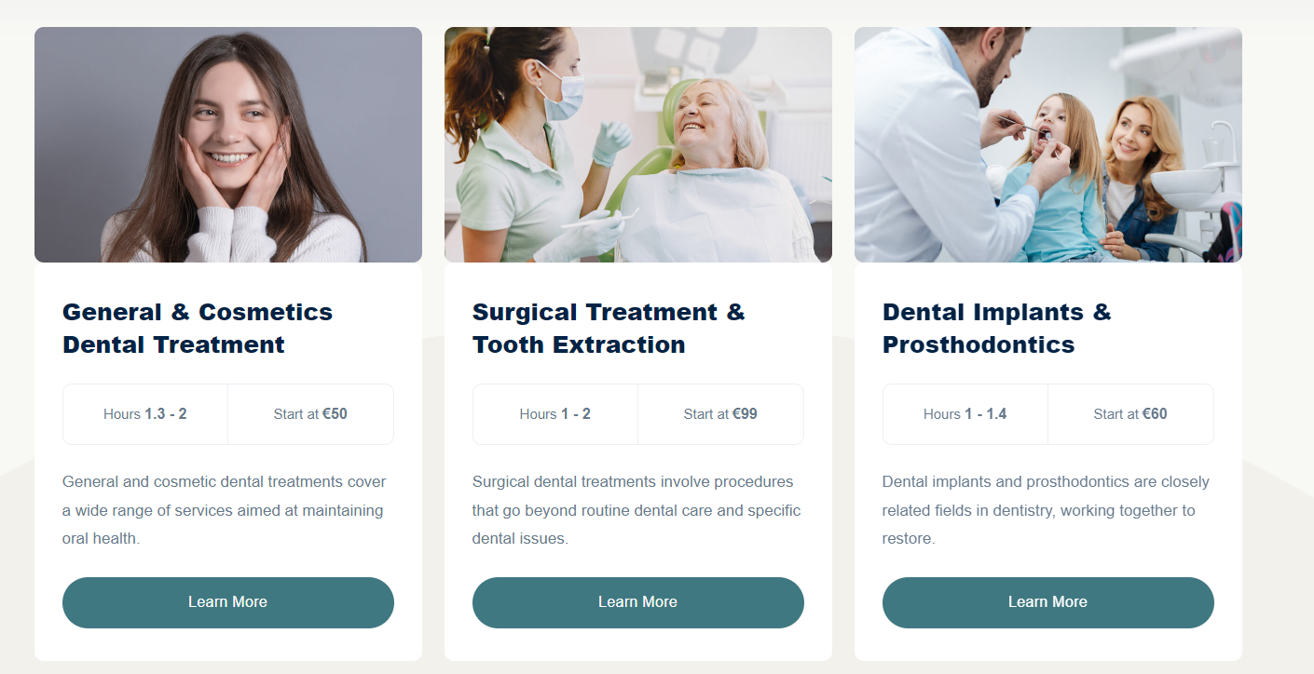

~~Section are~~

1. ~~General dentistry~~
2. ~~Composite bonding and Cosmetic Treatment~~
3. ~~Dental Implants~~
4. ~~Orthodontics~~

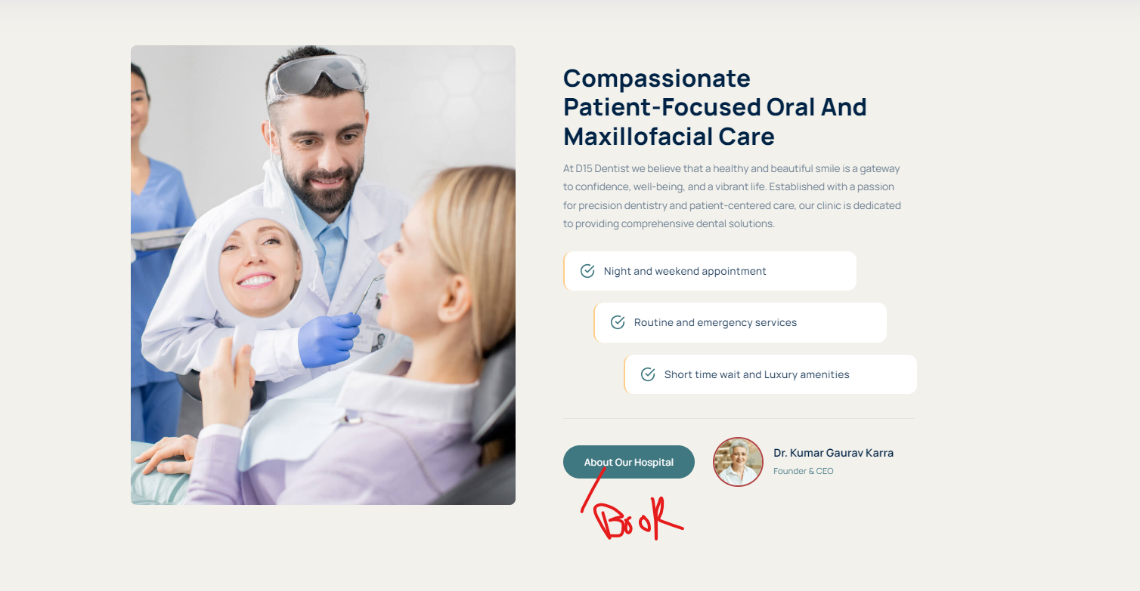

Update text –

Heading – Orofacial Pain, TMDs and Sleep apnoea

Orofacial pain refers to any pain around the face or inside the mouth that may not be dental in origin.

Disorders of the temporomandibular joint (TMJ) disorders (jaw joint disorders)-  
The jaw joints are referred to as Temporomandibular joint ( TMJ) and therefore any problems related to the TMJ is called TMJ disorder or simply TMD(Temporo Mandibular Disorders). TMD’s include stiffness in Jaw joints, clicks or noises in the jaw joints, pain while eating, inflammation and locking of joints (open lock and closed lock).

Muscular pain & Stiffness in the jaw & face-  
Over worked and stressed muscles are the most common reason for muscular pain around the face, in the absence of any infection, injury or pathology. An interesting fact is that this pain can mimic a tooth pain or be referred to a dental region.  
  
  
Clicking and / or locking in the jaw joint

One of the most common complaints is clicking of jaw joints, with more predilections for females. Sometimes it is minimal and in some people it could be loud enough to be heard in the next room. The clicks may sometimes be painful and almost always are caused by the displacement of the disc in the jaw joints. Many times it may not need treatment; however, in cases of degenerative changes, it may lead to locked jaws. Both open and closed lock jaws.

Neurovascular pain affecting the face  
Trigeminal & other Facial Neuralgias (Nerve Pain)

Trigeminal neuralgias are the most common cranial neuralgias causing sudden, usually one sided, short lasting but very severe and recurrent pain on the facial region. Electric shock like symptoms are the most common complaints. Attacks of pain may occur during simple activities like washing the face, tooth brushing or shaving. These sensitive areas are called trigger zones.

Neuropathic (Nerve) Pain following injury to the nerve  
sometimes a nerve injury within the nerves of the face can lead to a neuropathic pain, and a region on the face or inside the mouth can become painful served by the injured nerve. Often, misdiagnosed and may lead the patients to seek out more unnecessary dental procedures often leading to multiple extractions or root canals, with no relief. Neuropathic pain due to injury of the nerve causes continuous pain with variable intensity and all possible sources of dental pain are usually eliminated by thorough examination to diagnose a neuropathic pain.

Sleep apnoea:

Restricted airflow in the back of the mouth during sleep causes snoring. Sleep apnoea is a disorder associated with snoring where the airflow may be completely blocked for few seconds to more than 10 seconds. It can be mild with only 5 events per hour to severe with more than 25 episodes occurring every hour. People with sleep apnoea will usually feel day time tiredness, negative mood, lack of concentration from mild sleep apnoea to developing risks of stroke, diabetes and hypertension in severe sleep apnoea. It is diagnosed by the sleep clinics in the hospitals, where the patients will sleep overnight with special aids to monitor various markers during sleep. Oral appliances for sleep apnoea are useful to effectively manage patients with mild to moderate sleep apnoea.

Remove

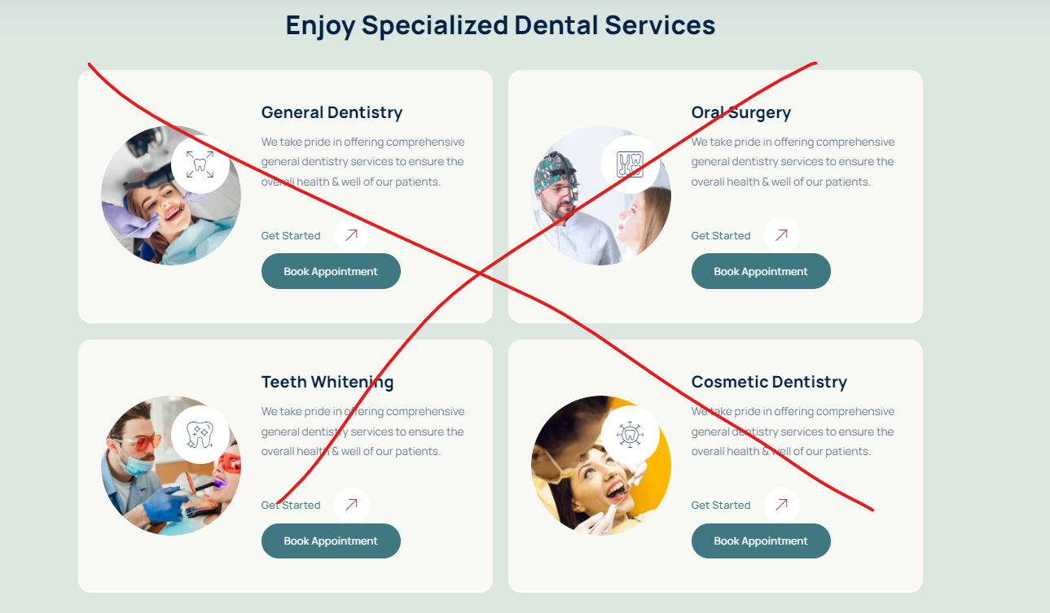

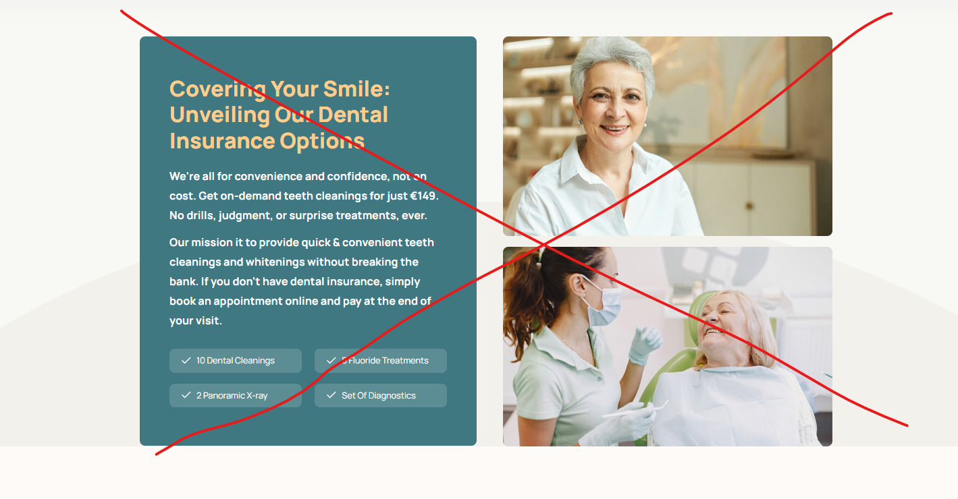

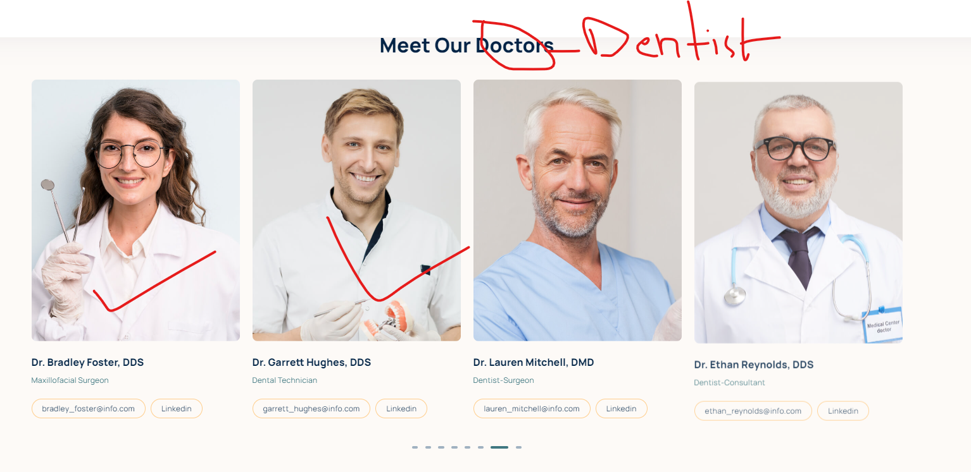

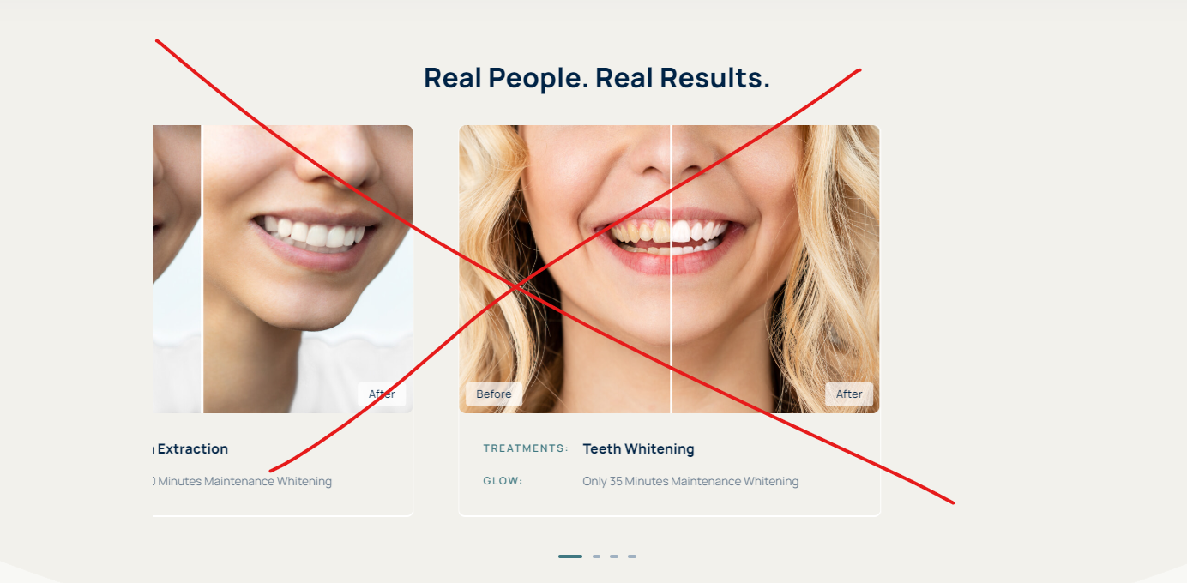

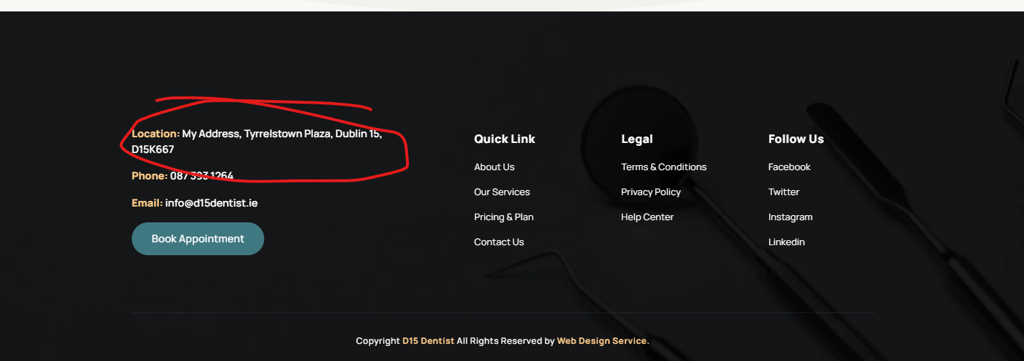

Phone no and address change.

2 Dentists and swap doctor with Dentists

**Page About us**

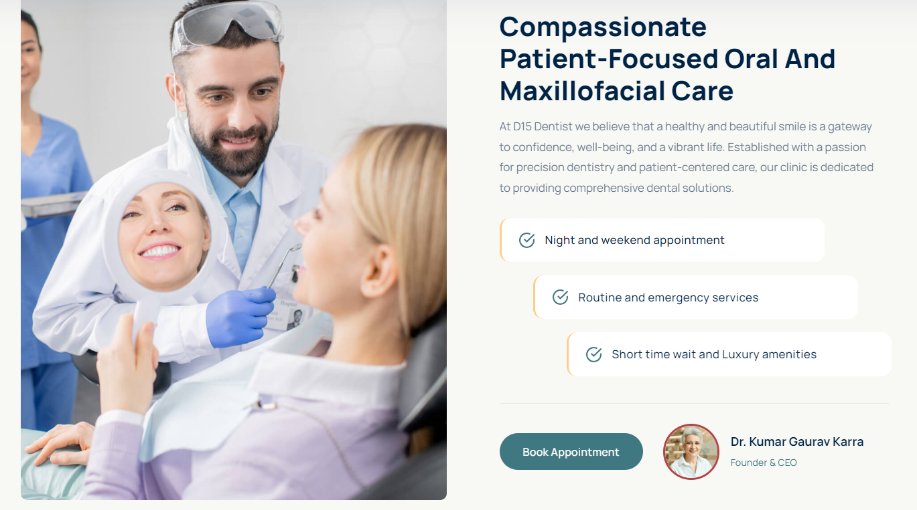

Heading and text

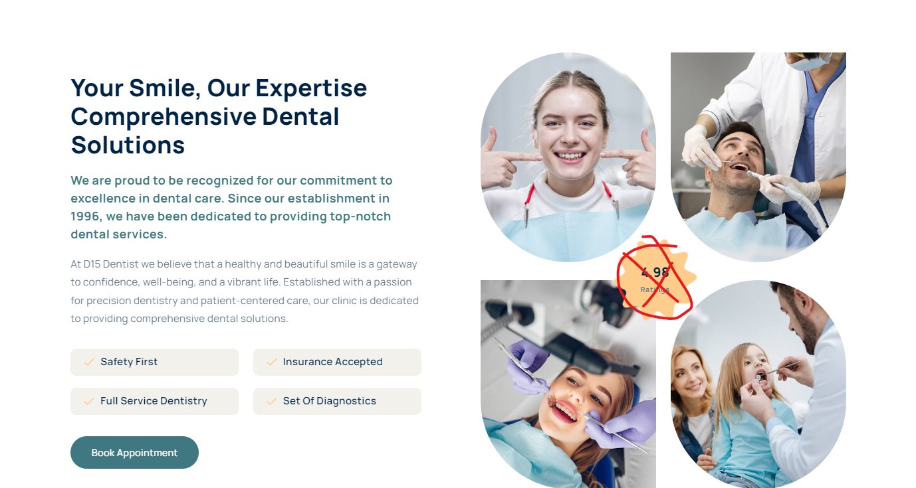

Heading text

Price List

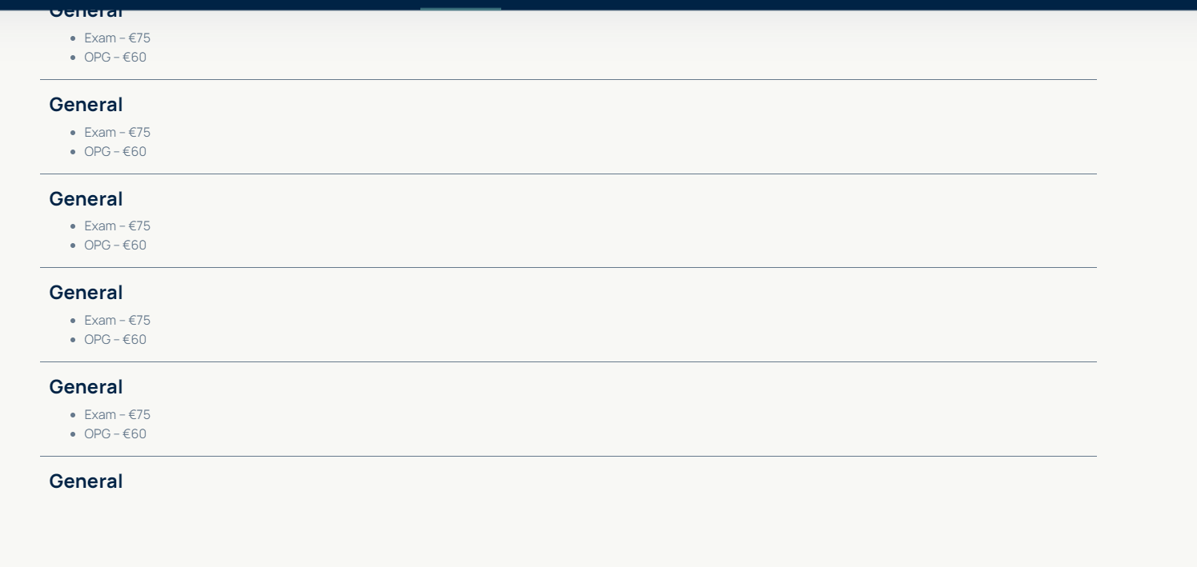

Update the price list

Services –

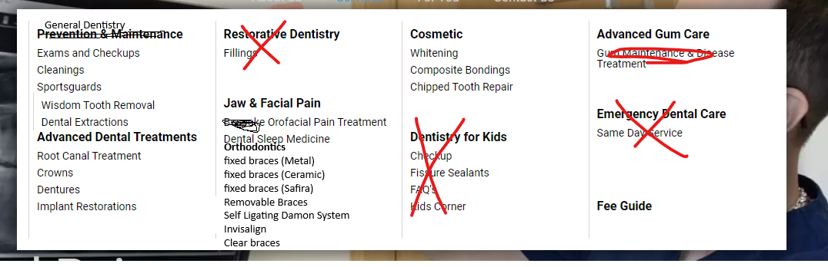

Menu - <https://roscamdental.ie/services/jaw-facial-pain/>

<https://www.enhance-dental.ie/price/>

<https://www.dentalcareireland.ie/practices/dentist-castlebar/prices/>

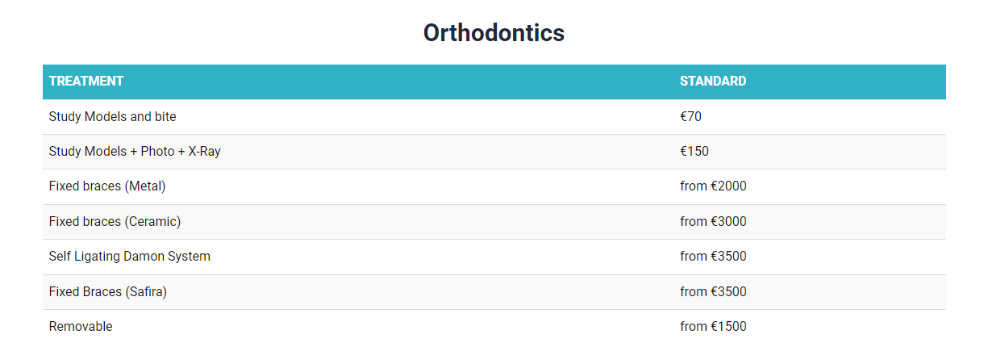

**Contact us**

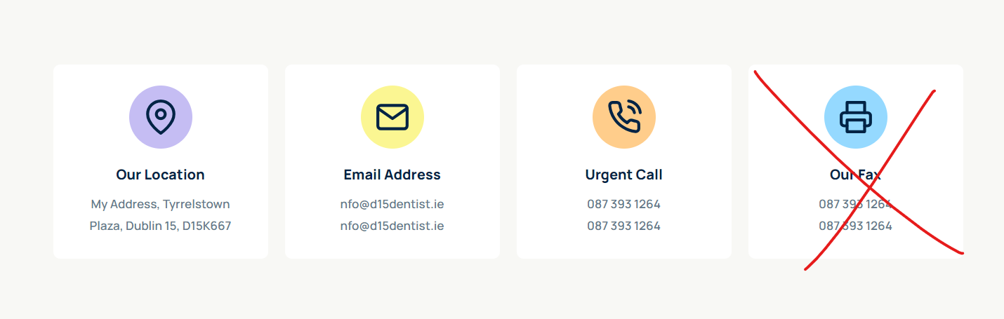

Email address swap by – Contact us (email and phone no)

Dentist profile

Sara and Dr Shaab

- Great that you have Before/after on the homepage. It's good also to have an additional before/after page on the website as well as add before/after to landing pages of each procedure where it fits, e.g. implants, bridges, bonding  
- On mobile the top line with contact details takes too much screen space. It should be reduced, ideally to one line.  
- If there is a possibility, add a "Make an appointment" button on the sticky top line on the mobile as well  
- On the address tab in the contact details page, add the "See location" button to the Google Maps below. Many people will not get to the map, as it's at the bottom of the page. Especially when browsing on mobile.  
- For the "Book an Appointment" page, delete fields: Preferred doctor (people usually don't know the names of doctors when it's a new clinic or a new patient.)  
- Add a review block on the home page and on every service page.

Doctor shaab

[**Dr. Kumar Karra**](https://www.smiles.ie/clinic/smiles-dental-dublin-15-blanchardstown/meet-the-team/)

Dr. Kumar Karra graduated from India in 2002. He spent more than 10 years working in his native country as a general dentist before moving to Ireland, where he started practicing dentistry in 2015. Through the years, Dr. Kumar has upskilled by doing many courses, including composite bonding, invisalign, Endodontics, restorative dentistry and dental implants. He has completed three distinct one year certificate programmes in Restorative Dentistry, Implant Dentistry and Orofacial pain. He has obtained Diploma of Primary Care Dentistry, qualified for Membership of the Faculty of Dentistry and also has a post graduate qualification of Membership in General Dental Surgery at the Royal College of Surgeons, Ireland. He is about to complete a Master’s Degree in Oro Facial Pain with Prestigious University of Southern California, Los Angeles. He provides treatment relating to TMD’s, Lock Jaws, Neuropathic pains, headaches and Sleep Apnoea. He is skilled in dealing with nervous patients.

Dr.Sara Flanagan  
  
With over 17 years of experience in transforming smiles, Dr Sara Flanagan is a highly skilled and compassionate orthodontist dedicated to providing personalised care for each patient. She has honed her expertise in a wide range of orthodontic treatments, including traditional braces, clear aligners, and advanced corrective procedures.  
Dr. Flanagan is committed to staying at the forefront of orthodontic innovation, regularly attending continuing educational courses and incorporating the latest techniques and technologies into her practice. Her patient-centered approach ensures that each treatment plan is explored to meet unique needs and goals of her patients, helping them achieve beautiful, healthy smiles.  
Beyond her technical skills, Dr. Flanagan is known for her warm and approachable manner, making every patient feel comfortable and confident throughout their orthodontic journey. Whether treating children, teens or adults, Dr.Flanagan strives to create a positive experience and lasting results.  
When she is not in the office, Dr.Flanagan enjoys staying active in the community, volunteering her time to promote dental health education and participating in local events. Her dedication to excellence in orthodontic care and her genuine passion for helping others make Dr.Flanagan a trusted and respected professional in the field.

1. General dentistry
2. Composite bonding and Cosmetic Treatment
3. Dental Implants
4. Orthodontics

**General dentistry**   
General dentistry focuses on good dental heal and adequate oral hygiene while taking care of issues like tooth decay, or a localised pathology in the mouth. It is recommended to have at least one routine dental exam every year with regular scaling and polishing on time intervals recommended by your dentist (usually 6 months)

1. Fillings – Dental filling is a general term used to repair a damaged tooth due to a cavity, trauma, wear due to excessive clenching/grinding or damage by hard tooth brushing. At D15 dental care, we only provide white composite fillings to match the color of the tooth as they are aesthetic, more natural looking and less obvious.

2. Scaling and polishing of teeth- it is a routine procedure to remove all plaque, tarter and calculus deposits from teeth coupled with polishing away all the external stains.

3. Extractions- both surgical and non-surgical- when the tooth cannot be saved due to damage/trauma or extensive caries, an extraction is usually required to prevent further pain or spread of infection. Occasionally, an extraction can also be recommended by the orthodontist during orthodontic treatment to align the teeth in the jaw.

4. Root canal treatments- when the tooth gets infected badly and its nerve(dental pulp) is involved, root canal is recommended to save the tooth rather than an extraction. The aim is to save a tooth that is within the limits of restoration and ensuring that the infection does not spread that may need a tooth extraction. During root canal treatment, this infected/damaged pulp tissue is cleaned out of the root canals of the tooth, with help of nickel titanium instruments, irrigated and washed out and replaced by inert filling materials to save the tooth. The dentist at D15 Dental care always describes the procedure before the consent is obtained. Depending upon the damage occurred to the tooth, it may need a crown, with or without a post core. Root canal treatment generally requires a few visits to the dentist.

4. Removal of uncomplicated wisdom teeth.- surgical and non-surgical removal of the wisdom teeth is done at the D15 dental care. Wisdom teeth are the most common teeth that may get stuck at a bad angle while erupting through the gums. This may lead to food impaction in the area and subsequent infection by opportunistic bacteria. This may lead to discomfort, pain, swelling, bad breath, limited mouth opening, headaches- all varying in severity depending upon the extent of infection. The patient will need to have a dental examination and an x-ray to check the wisdom tooth for a treatment plan.

5. Dental bridges- they offer a good means to close the gaps left by missing teeth and is usually a second choice for fixed prosthesis, after dental implants to close the gaps.

6.Crowns- a crown is a dental prosthesis that is glued to the outer surface of the tooth to give it added strength and also can give the tooth a new look as the crown completely covers the natural tooth. They can be made of porcelain, metal ( steel, gold or an alloy) or a combination of the metal and porcelain.

7. Partial and complete dentures for missing teeth- they are custom made oral appliances to replace missing teeth and are removable. The patients are advised not to sleep with the dentures in their mouth. Please ask your dentist for more details.

**Composite bonding and Cosmetic Treatment**

Composite bonding is a term that is used to describe the application of special white fillings on the front of the tooth to make it whiter and change its contours. The white fillings are glued to the front of the tooth and this procedure is reversible as it does not involve any shaving of the tooth surfaces unlike in the porcelain veneers. The composite bonding can be completed in a single appointment depending upon the number of teeth involved. At D15 dentist, we provide a free consultation for patients who are looking into composite bonding.  
  
Porcelain veneers are also part of the cosmetic treatment as they are long term solution but they require a part of enamel to be shaved so that an impression can be sent to lab for fabrication of the veneers. This procedure usually requires two dental visits.  
  
Cosmetic treatment also includes teeth whitening. There are 2 types of teeth whitening procedures recommended by the D15 dental care.

home based option- teeth whitening gels are provided with custom made whitening trays and the patient will use it at home  
office based option- teeth whitening is carried out in the dental office on pre fixed appointment and usually lasts around 1 hour.

Botox treatments- at D15 dental care, we are planning to include botox injections for management of wrinkles. Please contact reception for further information  
  
**Dental Implants**Dental implants are specialised dental prosthesis, that replaces single missing tooth or multiple missing teeth. It consists of 2 parts, a specially treated titanium screw that replaces missing root part in the jaw bone and the visible part/crown that is placed on top of the screw. They are a long term fixed solution for the missing teeth and at the moment are the most technologically advanced option present. An implant looks natural, is independent of any other tooth, free of any adhesives and require minimal maintenance. Your dentist will access the suitability for dental implants and patients will require a thorough examination. At D15 dental care, we provide a free implant consultation.

**Orthodontics**

A full page of orthodontic options have been emailed 8 december.